***Implementation of Access Modifiers:***

**Private:**

**Code:**

package defaultPackage;

class Data {

// private variable

private String name;

}

public class Main {

public static void main(String[] main){

// create an object of Data

Data d = new Data();

// access private variable and field from another class

d.name = "Programiz";

}

}

**Output:**



**Public:**

**Code:**

package defaultPackage;

class Data {

// private variable

//private String name;// Provides private access.

public void display() {

System.out.println(" hi, I am public access specifier");

}

}

public class Main {

public static void main(String[] main){

// create an object of Data

Data d = new Data();

// access private variable and field from another class

//d.name = "Programiz";//throws an error.

d.display();

}

}

**Output:**

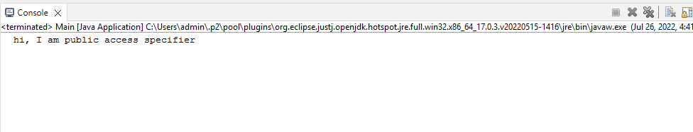

**Protected & Default:**

**Code:**

package defaultPackage;

class Data {

// private variable

//private String name;// Provides private access.

void message(){

System.out.println("This is a message");//default

}

protected void display() {

System.out.println(" hi, I am public access specifier");

}

}

public class Main {

public static void main(String[] main){

// create an object of Data

Data d = new Data();

// access private variable and field from another class

//d.name = "Programiz";//throws an error.

d.display();

}

}

**Output:**

